Place of competition: | Skien, Norway 2025
Team Country: | Germany

images for ID
  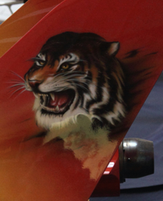
  
Skywalker | name | name | name
Select an item | Select an item | Select an item | Select an item
name | name | name | name
Select an item | Select an item | Select an item | Select an item
name | name | name | name
Select an item | Select an item | Select an item | Select an item

images for ID
name | name | name | name
Select an item | Select an item | Select an item | Select an item
name | name | name | name
Select an item | Select an item | Select an item | Select an item
name | name | name | name
Select an item | Select an item | Select an item | Select an item

